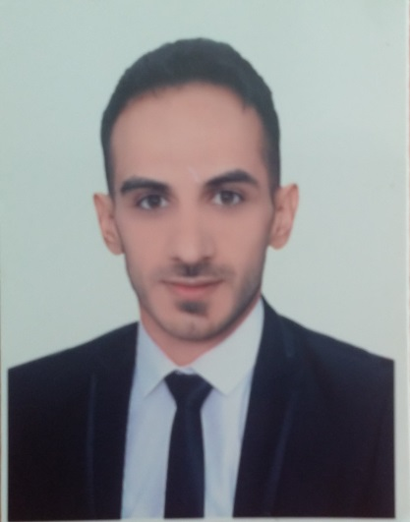 

* **ARABIC** (Fluent)

**Read/write/ Speak**

* **English** (Fluent)

**Read/write /Speak**

**LANGUAGES**

* **Surveying tools**

Level/ Total Station / Theodolite

* **Computer Programs**

Office programs :Word ,Excel , PowerPoint

AutoCAD

**Skills**

* **Civil Engineer Site Supervisor**

**Employer** : Al Hur Company For Construction

Jan 2013 – March 2014

**Project :** Multi-Purpose Building For youth and sport Ministry

**Location :** Karbala

* **Site Inspector Engineer /Quality Control Engineer**

**Employer** : IOS Engineering Consultant Company

May 2014 – July 2015

**Project :** Imam Hussein Oncology Centre

**Location :** Karbala

* **Sales Accountant / Salesman**

**Employer** : Wardt Baghdad Company for general trade

Dec 2015 – July 2017

**Project :** --------

**Location :** Baghdad / jameela

**WORK EXPERIENCE**

* **University of Technology**

Bachelor Degree In Building and Construction Engineering

2012 class

**Civil Engineer**

**EDUCATION**

**Ali Mohammed Radhi**

Iraq / Baghdad

09/01/1989

Agi2013n@gmail.com

07704319855